**The Gatehouse: Effectiveness of peer support for 2SLGBTQIA+**

**survivors of childhood sexual abuse**

Tishana Lynch, Lily Shulman, Shannon Squire, Tracy Tozer

N01138006, N01414447, N01428401, N01550358

Faculty of Social & Community Services

Humber Polytechnic

CDEV-4005: Senior Level Thesis Seminar

Professor Christine McKenzie and Linda Hill

March 26th, 2025

**Abstract**

Prior research has shown that people who identify as part of the 2SLGBTQIA+ community experience childhood sexual abuse (CSA) at a higher risk than heterosexual identifying people. Due to heteronormative societal views, the 2SLGBTQIA+ community is often expected to fit into the ‘norm’ rather than have their own unique needs met. This report provides insight into the experiences of past and present 2SLGBTQIA+-identifying participants from the Phase 1 15-week peer support program at The Gatehouse in the past three years. The research team set out to answer four research questions around how the participants were impacted, if there were barriers and needs not considered, what worked well, and what didn’t during their participation in the peer support group. A 12 question survey consisting of qualitative and quantitative questions provided the opportunity for 18 participants to share their experiences in their own words, increasing empirical evidence that addresses a current gap in literature for support-seeking participants whose identities are outside of the gender binary. The research concluded that The Gatehouse provides excellent support to survivors of childhood sexual abuse. At the same time, there is a need for more visibility and inclusion of the 2SLGBTQIA+ community, as well as for mindfulness around heteronormative policies and microaggressions that affect this community externally and internally. Showing a need for embracing an intersectionality framework when working with this population, further empirical research is needed to expand the findings of this report and increase knowledge and awareness for support providers to reduce unintentional harm.

*Keywords***:** Two Spirit, Lesbian, Gay, Bisexual, Transgender, Queer, Intersex, Asexual (2SLGBTQIA+), Childhood Sexual Abuse (CSA), 2SLGBTQIA+ Peer Support Groups, Heterogenous Community, Intersectionality, Heteronormativity, Microaggression, Minority Stress Theory.

**Acknowledgments**

The researchers would like to thank every single one of the participants for taking the time to share their experiences and for being the heart of this research project. The researchers also thank Maria Barcelos, Executive Director of The Gatehouse, for all of her time, encouragement, knowledge sharing and support throughout this process. The research team would also like to thank Erin Lockhart, a hard working placement student at The Gatehouse, for her input as well as all the staff, volunteers, and other placement students who contributed to the project's success. The research team would like to thank professors Linda Hill and Christine McKenzie for their feedback, instruction and encouragement. The research team would also like to thank Stefan Horodeckyj, former group facilitator and director at The Gatehouse, for his previous research and expertise that informed this project.

**Table of Contents**

**Introduction 6**

**Methodology 9**

**Results 13**

**Discussion 21**

Importance Of Intersectionality 21

Unique Needs of a Heterogeneous Community 22

Visibility & Inclusivity 23

Heteronormativity & Microaggressions 24

Recommendations 25

Conclusion 28

Limitations 28

**References 30**

# **Introduction**

The Gatehouse, a social service organization located on Humber Polytechnic campus, has been providing support, community, and resources to adult survivors of childhood sexual abuse (CSA) since 1998. A team of four senior students in the Community Development program at Humber Polytechnic partnered with The Gatehouse to evaluate their Phase 1 peer support group offered to adult survivors of CSA who identify as a part of the Two Spirit, Lesbian, Gay, Bisexual, Transgender, Queer, Intersex, Asexual, Plus community (2SLGBTQIA+). The purpose of this research was to answer the following questions; How were 2SLGBTQIA+ participants impacted by attending the peer support program? Were there any barriers to accessing the peer support program as a 2SLGBTQIA+ identifying person? Were their needs not considered in peer support sessions that should be included or addressed? What worked well and what could be improved to better support 2SLGBTQIA+ CSA survivors?This research will provide The Gatehouse with crucial insights into enhancing the experience and healing for 2SLGBTQIA+ identifying survivors who are seeking support for CSA at The Gatehouse, applying the Myers “Minority Stress Theory” as a framework for working with the 2SLGBTQIA+ participants of their programs. Minority Stress Theory is an explanatory theory aimed at understanding the social, psychological, and structural factors accounting for mental health inequalities facing sexual minority populations (Frost & Meyer, 2023).

According to literature, members of the Lesbian, Gay, Bisexual, and Queer (LGBQ) community are at a higher risk of experiencing childhood sexual abuse (Walker et. al, 2012). Some studies have found that their rates are up to 1.6 times higher than those of the general population (Vanderbilt University Medical Center, 2024). This statistic proves how crucial this research is and highlights the importance of making sure that members of the 2SLGBTQIA+ community know that they’re valid, seen and heard when healing from CSA. Research states, validation of an individual’s chosen identity directly impacts their motivation and interest levels when participating in group programming, potentially impacting and creating barriers along their healing journey (Schreuder, 2021). This explains how important it is for 2SLGBTQIA+ survivors to feel included in peer support spaces as well as how various intersecting social identities connect and impact the healing process for CSA survivors. Intersectionality is the complex, cumulative way in which the effects of multiple forms of discrimination (such as racism, sexism, and classism) combine, overlap, or intersect, especially in the experiences of marginalized individuals or groups (Oxford language, 2024). Literature also highlights that peer support is a beneficial and strong program model preferred by the 2SLGBTQIA+ community as it “minimizes their fear of discrimination, isolation and coming to terms with their identity” (Borthwick et al., 2020, pg. 9). Peer support also assists participants in getting past emotions such as shame, guilt, and isolation by providing them with a community that has useful coping mechanisms (de Van et al., 2023).

While peer support is the preferred method of support according to the literature, there is still a risk for potential harm due to heteronormative biases, assumptions, and stereotypes that produce microaggressions (Fisher et al., 2019). Microaggressions are an indirect, subtle, or unintentional comment or action of discrimination against members of a marginalized group (Merriam Webster, 2024). Microaggressions are often dismissed and their harms are often minimized (Fisher et al., 2019). The effects of experiencing microaggressions every day, multiple times a day, causes internal negative beliefs about one’s self for members of the 2SLGBTQIA+ community (Fisher et al., 2019). It is also known that current language practices construct models of inclusion and exclusion even through what is unspoken, and microaggressions often go unnoticed by the majority in heteronormative programming (Schreuder, M. C., 2021). Another term often used throughout the research is ‘heterogeneous’, because 2SLGBTQIA+ identity is not a single homogeneous experience, but rather a broad and diverse set of experiences and needs (Borthwick et al., 2020). Cisgender identity and heterosexual orientation is considered the norm and most preferred in today's patriarchal society, it is the dominant culture that most support programs are based in, throughout the research analysis this cultural context is referred to as heteronormativity.

The Gatehouse aims to compassionately serve the 2SLGBTQIA+ population. This research will highlight the importance of increasing visibility and inclusivity, as well as addressing intersectionalities, heteronormativity and microaggressions, and the unique needs of a heterogeneous community, in order to enhance their program experiences. The data shared in this report will help The Gatehouse meet their goal of creating a welcoming and encouraging environment for all survivors, particularly those in the 2SLGBTQIA+ community who often face additional difficulties and barriers throughout their healing process. This report will disclose the research process and include a complete analysis of the research findings and recommendations, serving as a road map for future improvements and expansions in services for 2SLGBTQIA+ survivors seeking support for CSA at The Gatehouse.

# 

# **Methodology**

The research team conducted a qualitative and quantitative 12 question survey in order to capture information about the experiences, challenges being faced and ideas for program improvement from the perspectives of 2SLGBTQIA+ participants of the Phase 1 15-week peer support program, ‘Out of the Darkness and Into the Light.’ The survey was designed using Google Forms software on the research team’s shared Google account, which allowed the community partner to also have access to raw data without compromising the confidentiality of participants. Paper copies, as well as survey-assistance either in-person at The Gatehouse or over the phone were offered to ensure that all participants wanting to participate in this research were able. The study originated from the research team’s interest in enhancing the voices of 2SLGBTQIA+ survivors of CSA and addressing the current gaps in literature surrounding this community’s experience in peer support group settings.

Survey questions were developed based on a literature review and thorough discussions with the community partner. Four staff members and program volunteers at The Gatehouse conducted a test version of the survey before the final was presented to the sample population. This feedback was used to minimize the risk of further harm to the participant(s) through the language used on the survey, and to improve the functionality and accessibility. The final survey contained a mix of four closed-ended and eight open-ended quantitative and qualitative questions. Survey responses were stored using Google Sheets, an online spreadsheet software.

From an epistemological standpoint, this study uses an interpretivist approach, meaning that the interpretation of reality is molded by social constructions including language, awareness and shared meanings (Sol & Heng, 2022). This approach to developing survey questions seeks to provide rich, in-depth insights from a smaller number of people (Sol & Heng, 2022). The focus was on co-creating knowledge about the unique needs and lived experiences of past and present 2SLGBTQIA+ participants who have accessed peer support through the Phase 1 program, as well as identifying any barriers to accessing services.

Participants were recruited anonymously and voluntarily in early 2025, through two outreach emails prepared by the research team and distributed by the community partner using an email delivery system. The first outreach email was sent out to 802 potential participants on January 22nd, 2025. 53% of recipients opened the initial email, and 14 people responded. After a reminder email was sent out to the 47% who didn’t open the first email on February 6th, 2025, five more responses were received. A poster was also prepared by the research team and posted around The Gatehouse with a QR code leading directly to the online survey. The inclusion criteria were individuals who: a) were past or present participants of the Phase 1 15-week peer support program “Out of the Darkness and Into the Light” in the last three years; b) Self identified as a member of the 2SLGBTQIA+ community; and c) were over the age of 18 years, as per the age requirements for this specific program.

The sample was determined using the cluster sampling method, as there were naturally two cluster groups, either 2SLGBTQIA+ identifying or non-identifying participants. Allowing participants to self-identify as a part of either cluster, ensured inclusiveness for participants’ whose identities may have changed since their initial intake process, or those who did not comfortable disclosing their gender identity and/or sexuality for any reason. This also ensured that the study maintained both confidentiality and ethical considerations. The final sample was composed of 18 participants. The research also relied on the snowball effect of participants engaging and encouraging other participants to complete the survey.

The research team applied a thematic analysis approach to “systematically identify and analyze recurring themes or patterns within qualitative data”. Researchers started by coding the data, breaking it down into meaningful segments, and then categorizing these segments based on shared characteristics (GeeksforGeeks.org, 2024). Multiple different coding strategies were applied to this phase of the research. The research team began by highlighting the keywords and phrases from individual responses by hand and manually sorted these responses into thematic categories. This process was also repeated using Google Docs to highlight keywords and phrases digitally. Voyant Tools software was then used to create a word cloud analysis of overall themes based on their frequency in survey responses. The research team also used built-in software features of Google Forms to create qualitative pie graphs to represent the data, as well as bar graphs to show the variation in sexual orientation and gender identities of the respondents. Data collected from the close-ended responses was analyzed to look for specific trends among demographic characteristics and participants’ experiences, as well as for a positive correlation between the method of program delivery and participant outcomes. Any and all data collected will be destroyed by Maria Barcelos no later than April 30th, 2025.

The study was approved by the Research Ethics Board at Humber Polytechnic and throughout the research project, researchers made a conscious effort to adhere to both the Humber Research Ethics Board and the Tri-Council Policy Statement TCPS 2 (2022) by ensuring all 3 key principles were a primary focus of the research. These principles are: a) respect for persons; b) concern for welfare; and c) justice. Prior to completing the survey, participants read a preamble prepared by the research team, ensuring implied consent. This preamble described the rationale and goals of the study, information regarding participants’ full confidentiality, the right to withdraw at any time, and crisis support numbers if needed when completing the survey. The contact information for crisis support was also included in both outreach email(s), whether recipients chose to participate or not. Participants’ were also reminded that their survey choices will not affect their ability to participate in the services and support provided by The Gatehouse. There were no required survey questions, meaning that participants were able to skip any questions that they didn’t want to answer, for any reason. Researchers engaged in individual and collective reflective practices throughout the research project to identify and limit any and all potential bias and limitations that could have been imposed by their own positionalities. No monetary compensation was provided.

# **Results**

19 surveys were collected. One survey was excluded due to sexual orientation being selected as straight and gender identity selected as a cisgendered woman. This response is excluded from Figures 3-7 but is included in Figures 1 and 2. Figure 1 depicts gender identity, where 36.8% of respondents identified as women, 42.1% identified as men, 15.8% identified as nonbinary, 5.3% identified as trans men, 5.3% identified as gender non-conforming, 5.3% identified as gender fluid. Figure 1 also shows that participants did not select the following options; Two-Spirit, trans-woman, agender or prefer not to answer.

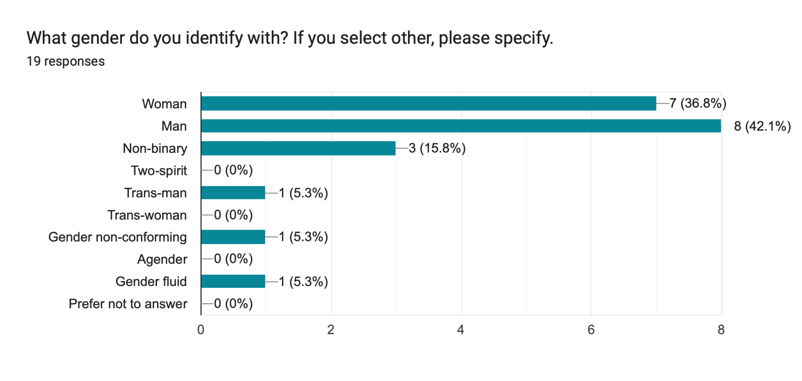Figure 1. Participant responses to survey question 1 regarding gender identity.

Figure 2. Participant responses to survey question 2 regarding sexual orientation.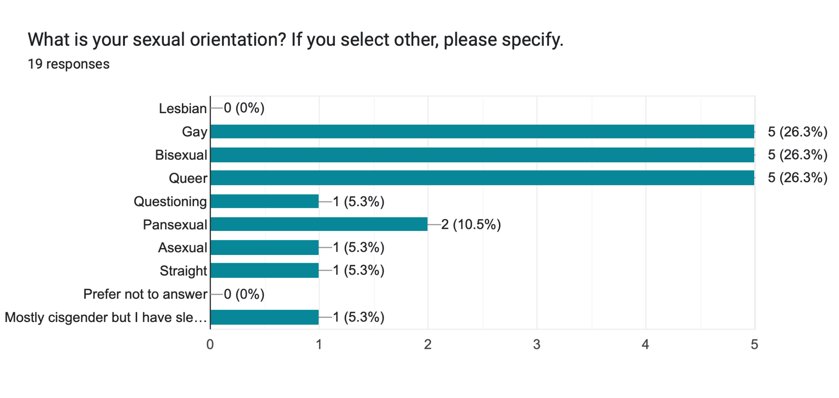

Figure 2 depicts sexual orientation, where 26.3% identified as gay, 26.3% identified as bisexual, 26.3% identified as queer, 10.5% identified as pansexual, 5.3% identified as questioning, 5.3% identified as asexual, and 5.3% identified with their own label. Figure 2 shows that no participants identified as a lesbian. Figure 3 shows how participants heard about The Gatehouse. 50% were referred by a professional source, 27% through internet and media and 22.2% by word of mouth. 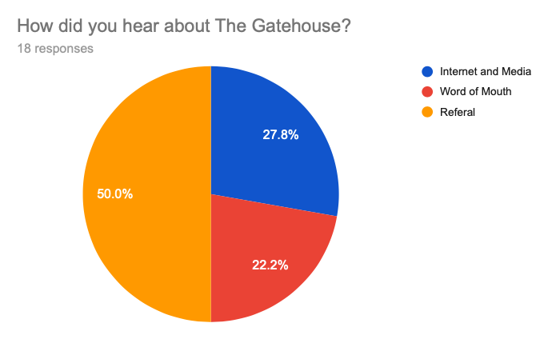

Figure 3. Participant responses to survey question 3 regarding how they accessed services at The Gatehouse.

Responses to the survey question, “Did you face any difficulties when seeking support for CSA either before, during or after completing the intake process,” showed that 11 out of 18 respondents did not have any difficulties. Some difficulties mentioned were "too many check in appointments," and "dealing with rising thoughts.” 16.7 % of respondents voiced specific sexual orientation and gender identity challenges such as “feeling like an outsider in the men’s support groups, due to being a trans man” and “never felt comfortable in the group identifying as gay.” 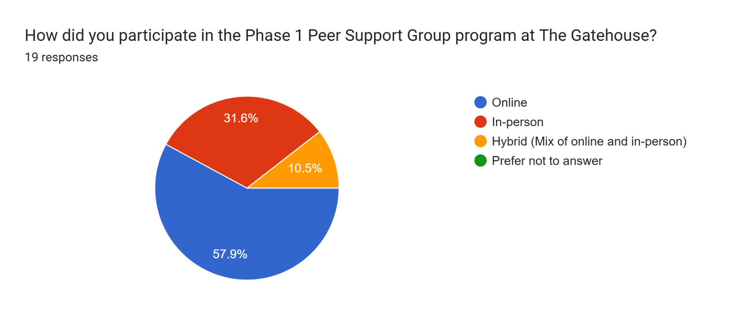

Figure 4. Participant responses to survey question 5 regarding the method of program delivery that they participated in at The Gatehouse.

Figure 4 shows that 57.59% (11) of respondents participated in the Phase 1 peer support group online, while 31.6 % (five) were in person and 10.5% (two) were hybrid, a mix of online and in-person. Of the 11 online participants, responses such as “Twice during the group sessions I had problems. Once I had to email about one person monopolizing the discussions, going off topic, and not being checked. Secondly, I was treated abusively and controllingly by another participant and the moderators didn't stop her until I asked them to” as well as “I feel that a greater connection would be achieved by having an option for a 2SLGBTQIA” both indicate that at times it was more difficult for facilitators to maintain a safe and inclusive space for members of the 2SLGBTQIA+ community in an online setting. Additionally, only four (36.4%) of these participants received any form of aftercare upon program completion, compared to 40% of in-person participants. While one of the responses from a participant in a hybrid program said, “I believe the group is better in person than online. I started the group in person, then Covid happened and it moved online. I think the in person sessions were better.” Ultimately there is not enough data from this research to come to a conclusion that there is a positive correlation between program methods and participant outcomes. However, the results of this research highlight the need for future research exclusively on this topic to confirm or deny this potential correlation.

When responding to the survey question “What do you think worked well to support 2SLGBTQIA+ survivors,” two respondents out of 18 stated “I don’t think there was anything specifically aimed at 2SLGBTQIA+ identities.” 22% of respondents felt that “knowing that facilitators were also survivors,” or “when one facilitator was openly queer helped them feel more comfortable.” Others comments included “open communication and acceptance”, “having group rules right at the outset, making it clear that it was intended to be a safe space”, and “inclusive language” being used worked well in their experience. Another participant shared that seeing rainbows and flags visible around the office and property helped them feel safe and respected. 17% of respondents explicitly stated they liked mixed groups. One respondent stated, “Nothing really, I did not feel supported as a gay man, “I did feel supported as a victim of childhood sexual abuse.”

27.7% of responses to the question “What could be improved, if anything, to better support 2SLGBTQIA+ survivors at The Gatehouse” felt that there was no need for improvement in the current program. A participant said “All good.” 38.8% mentioned various recommendations for increased visibility and inclusion of 2SLGBTQIA+ voices. These examples were a group specifically for 2SLGBTQIA+ people, understanding intersectionality with BIPOC, and having “at least one 2SLGBTQIA+ facilitator” present. Participants were asked what topics would have enhanced their healing, a variety of topics were mentioned by 14 out of 16 respondents including an “understanding [of] CSA and impacts on sexuality and gender”, harmful myths, and “relationships with partners of the same sex as abusers and how to deal with the triggers, closeness, hypersexual and vulnerability.” Other topics such as “how complex healing may look on a daily basis" and linking personal stories and experiences in the manual to 2SLGBTQIA+ experiences were also mentioned.

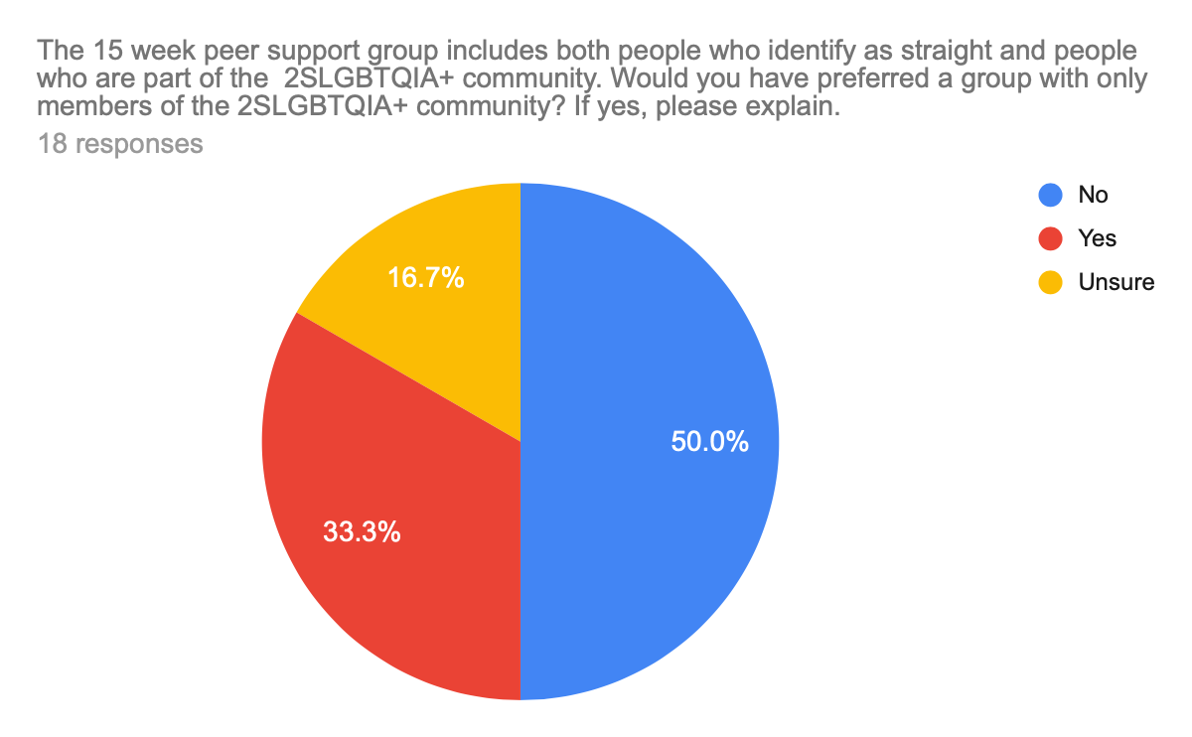

Figure 5. Participant responses to survey question 9 when asked if they would have preferred the option for a 2SLGBTQIA+ specific peer support group at The Gatehouse.

Figure 5 depicts that 33.3% of respondents would have benefited from a specific 2SLGBTQIA+ peer support group, with participants stating that “I would feel safer with my experiences and more comfortable sharing openly without feeling like I need to hide my transness,” and “yes…Straight men sometimes cannot relate and I am tired of explaining and educating when I am vulnerable and need support.” 50% stated ‘no’, “Straight people have valuable insights, experiences, I felt accepted by all,” and “I personally like the mixture.” 16.7% were unsure, with one participant stating “Yes, I was the only one identified as gay and that left me feeling a bit unconnected… But it was also helpful to hear and understand it from the other side.

Participants were also asked if there was anything that they would like the staff and facilitators at The Gatehouse to know. There were requests for more information on neuroscience of trauma and healing, CSA effects on sexuality, and introducing individual sexual orientations at the first meeting. Participants also shared their experiences of microaggressions, particularly within heteronormative spaces, and emphasized the need for facilitators to recognize these issues. One respondent expressed, “I never felt comfortable in the group identifying as gay” while another participant felt that a discussion they were involved in was from the “straight perspective” and stated “It would have felt better to have had a gay facilitator in the mix to get our side of the issue into the discussion.” One participant commented that they felt they were treated in a condescending or not empowering manner which made them feel excluded for being not far enough in their healing journey. While 16.6% of other participants shared positive comments that facilitators were validating, encouraging and “amazing already.”

Figure 6. Participant responses to survey question 11 regarding if they received any form of aftercare upon completion of the Phase 1 peer support group.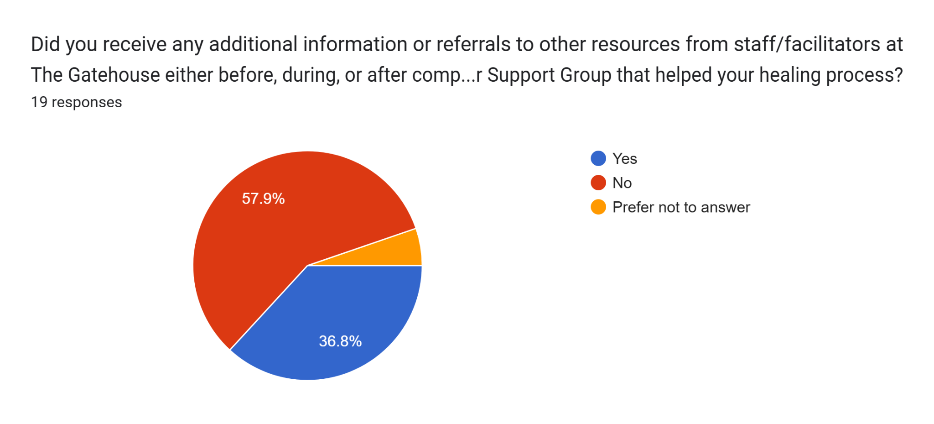

Figure 6 speaks about whether or not participants received additional information or referrals to other resources from staff and facilitators at The Gatehouse. 58% of respondents stated they did not receive additional information or referrals, 36.8% stated yes and mentioned various book recommendations, handouts in the manual, recovery referrals, websites, conferences, youtube videos, and 1x1 counselling options as examples of what was provided to them. This is represented in figure 7 below. 5.2% preferred not to answer.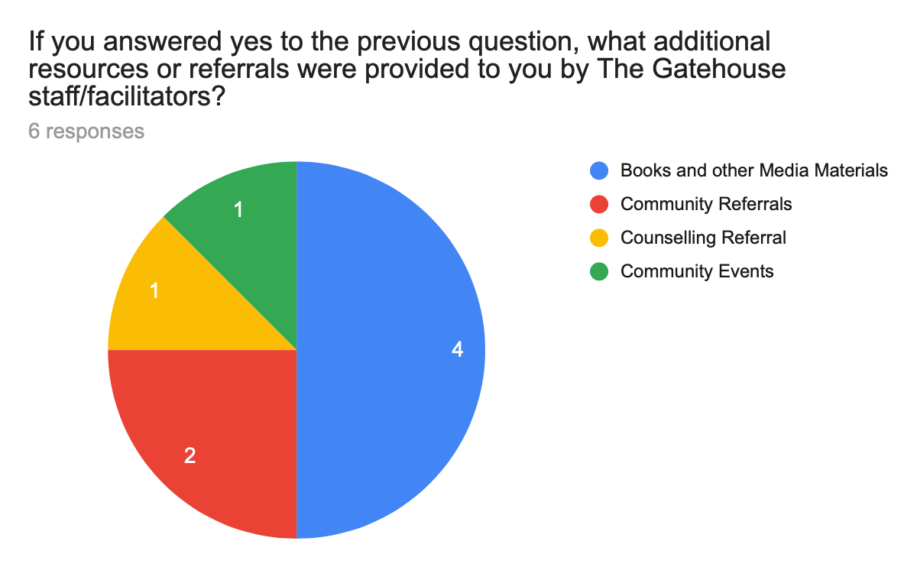

Figure 7. Participant responses to survey question 12 regarding what types of aftercare were provided.

While 50% of respondents felt that they would not have benefited from a specific 2SLGBTQIA+ peer support group, only 22% felt everything about the program was “perfect” and there was “no need to change anything”. Overall 78% of respondents felt that there could be more visibility and inclusion of their lived experiences in the program context which they feel would enhance their healing.

# Discussion

The Gatehouse’s mission is to create a safe place and to foster a welcoming environment where CSA survivors can share their stories. The Gatehouse also serves 2SLGBTQIA+-identifying CSA survivors and wants to ensure that these participants can share their personal stories without hesitation in predominantly heterosexual peer support groups. This research aims to promote an understanding of visibility, inclusivity, and the unique needs of a heterogeneous community. As well as, the importance of recognizing intersectionalities and the impacts of heteronormativity and microaggressions, to ensure that this community feels valued and supported in peer support group settings.

The data also showed the impacts of a heteronormative space and how microaggressions, while maybe not intentional, are experienced. Increased awareness and understanding of the intersectionalities of individuals is necessary to provide a safer space for all to feel welcomed to be themselves. Participants of this research have voiced such needs as 2SLGBTQIA+ individuals, even while praising the support they did recieve as a survivor of CSA.

## Importance Of Intersectionality

The focus of this research is to explore whether 2SLGBTQIA+-specific support groups should be introduced at The Gatehouse. The data gathered shows that a 2SLGBTQIA+-specific group would be of interest to some members of this community. A targeted approach could address the unique challenges faced by the community and provide a more inclusive and supportive environment. Responses raised the need for greater awareness of how social identities connecting participants' subjective elements, including race, gender, identity, and sexual orientation influence their experiences of trauma and healing. Intersectionality is not currently a predominant focus of The Gatehouse peer support group. Phase 1 topics include trust, building emotional resilience, anger, inner child, shame, guilt, boundaries, and moving beyond trauma (The Gatehouse, 2025). 2SLGBTQIA+ specific topics such as the impact of CSA on sexuality, hypersexuality, relationship formation, and harmful myths about this community were named as potentially beneficial topics for future group members.

Some participants shared that by not addressing these topics, it may leave some individuals feeling unsupported. For instance, one respondent felt that the 2SLGBTQIA+ impacts were not discussed during the session, and as a survivor, they felt excluded and that their needs were not prioritized. As per Schreuder (2021), when supporting 2SLGBTQIA+ people it is important to use language to build safer spaces, claim their power, and fight persecution. For example, reclaiming words like ‘queer’ helps them to empower and fight negative stereotypes (Schreuder, 2021). This underlines how language may enable 2SLGBTQIA+ groups to create identity and fight for inclusivity. Walker et al. (2012) also explored intersectionality using minority stress theory to examine the impact of CSA on 2SLGBTQIA+ survivors. The text stated that discussions surrounding identity, sexual identity formation, and sexual orientation as well as ethnicity, race, gender, sexuality and societies perpetuation of heteronormativity are necessary and important to deepen self-awareness and healing for survivors of CSA (Walker et al, 2012).

## Unique Needs of a Heterogeneous Community

As a whole the 2SLGBTQIA+ community is large and very diverse, in literature this is identified as a heterogeneous community. The acronym encapsulates various sexual orientations as well as gender identities of people spanning generations, so varying needs and opinions are inevitable (Turner and Hammersjö, 2024). This research demonstrated varying opinions by 2SLGBTQIA+ participants, which may make it more challenging to design a peer support program that effectively meets everyone’s unique needs. It is important to note that one solution may work for some, but not for all (Turner and Hammersjö, 2024). Sensitive facilitation and careful awareness of the environment are important for group discussions or individual sessions, and lessening the potential for 2SLGBTQIA+ participants feeling uncomfortable. Sokol and Fisher’s (2016) research included the notion of being ‘hardly reached’ to highlight institutional shortcomings rather than individual resistance. This literature states that “The failure of prevention and treatment programs to reach those they are intended to help contributes to avoidable yet substantial costs," (Sokol & Fisher, 2016, p.2), supporting the conclusion from this research that current peer support programs are addressing the needs of individuals as CSA survivors but not as 2SLGBTQIA+ individuals. Due to varying perspectives as a result of their heterogeneity, this supports the claims of this research that The Gatehouse should provide multiple program options to ensure that they can address the unique needs of all participants from this community.

## Visibility & Inclusivity

It was interesting to note that while 50% of respondents indicated that the existing group program was helpful and there was no need for a 2SLGBTQIA+-specific group, 78% of all respondents indicated some form of difficulty or suggested changes to the existing Phase 1 program. This finding suggests that while 2SLGBTQIA+ participants are included in existing programming at the Gatehouse, the existing program model is not addressing participants’ desires to be seen and represented within program topics and materials. The literature revealed that 2SLGBTQIA+ individuals feel safer within a support group setting (Shultz, 2020), highlighting the importance of work being done at The Gatehouse and how this research will enhance 2SLGBTQIA+ experiences in the peer support groups. As 2SLGBTQIA+ survivors shared hesitance in being authentic in the group space, this may indicate a potential fear of being judged or not seeing themselves reflected. Therefore, highlighting the importance of visible and inclusive spaces for 2SLGBTQIA+ identifying CSA survivors at The Gatehouse. Creating spaces where the 2SLGBTQIA+ community sees themselves helps to build acceptance, trust and respect (Sokol and Fisher, 2016). Literature explains that programs focused on shared identities and respect keep more people engaged than programs without these adjustments (Wukelic, 2025)(Sokol and Fisher, 2016). Safer spaces are highly important to have as they are necessary for people to feel supported and heard (Wukelic, 2025). This was also supported by Walker et al. (2012) who determined that healing is enhanced for the 2SLGBTQIA+ population when participants can be open about their sexual orientation.

## Heteronormativity & Microaggressions

Furthermore, for groups to be safe and welcoming places for 2SLGBTQIA+ individuals, organizations need to consider that these individuals have experienced various and ongoing forms of microaggressions and discrimination (Woo, 2024). Individuals may be reluctant to participate fully in programming due to heteronormative policies and procedures in places that they feel misrepresent them (Blackburn et al., 2024). As microaggressions often go unnoticed by the majority in heteronormative programming (Schreuder, 2021), research has shown that having peer support programs led by facilitators who also identify as a part of the Lesbian, Gay, Bisexual, Queer community results in staff being more responsive to the specific issues faced by members of the community (Worrell et al., 2024).

Regarding the impacts of embedded heteronormative practices, Parmenter and Winter (2023) applied the Minority Stress Theory framework to explain that while 2SLGBTQIA+ individuals can and do face discrimination from within their own community, internal stresses were not found to impact the individuals’ mental health as severely when social identity factors were taken into consideration. Whereas, external cisgender and heterosexist discrimination had negative impacts on their mental health either way. Blayney et al., (2023) further explain that combining Intersectionality theory and Minority Stress Theory highlights that the lasting effects of sexual violence were found to be greater among 2SLGBTQIA+ individuals with multiple marginalized identities, which can lead to worse outcomes for participants in peer support group programs (Wukelic, 2025). This highlights the need to create a safer space for 2SLGBTQIA+ individuals rather than solely focusing on cis hetero dominant norms and culture (Parmenter & Winter, 2023).

## Recommendations

The participants in this research strongly voiced their unique needs. It is encouraged that The Gatehouse applies the following recommendations to enhance program content about 2SLGBTQIA+ CSA survivors’ lived experiences, including identity formation, and how the intersections of ethnicity, race, and gender impact the healing process from CSA. Having members from the 2SLGBTQIA+ community contribute their ideas and voices in this process helps the organization to develop inclusive and supportive policies. One way to develop that is to have inclusive group rules acknowledged and agreed on at the beginning of the program, as suggested by 2 survey respondents. At the beginning of the group session, an opening statement such as "this group is a safe place for all identities including 2SLGBTQIA+ individuals", can establish the tone and clarify the inclusivity of the group. The group rules are to make people feel that the environment is a safer space for all.

Further training of staff and facilitators at The Gatehouse would be helpful to increase knowledge and awareness of heteronormative biases and assumptions. One common assumption is assuming that everyone fits into standard gender or sexual orientation norms. This recommendation was also present in the literature for this research as strategies to improve volunteer and staff competencies resulted in 2SLGBTQIA+ participants reporting less barriers and gaps in peer support programming (Jivanjee et a., 2020).

For The Gatehouse to create a welcoming and effective program for 2SLGBTQIA+ participants, it’s important to start by asking participants what their needs are. This can be done through follow-up focus groups or additional surveys. Literature shows that comprehensive surveys are vital for developing programs using an intersectional approach that is effective for all subpopulations within the 2SLGBTQIA+ community (Blackburn et al., 2024). Currently, The Gatehouse is conducting focus groups within their programs and a focus group with 2SLGBTQIA+ participants could be beneficial to gather a deeper understanding of their needs. Encouraging participants to give qualitative feedback, through post-group surveys, will provide on-going details and information about how the program can continuously improve.

Additionally, providing participants the choice to join a mixed group or a 2SLGBTQIA+ specific one when they enter the program can make them feel more empowered to participate and embrace their intersecting identities. 2SLGBTQIA+ participants might prefer a space just for their community thus lessening potential fears of discrimination and harm (Borthwick, et al., 2020). The fact that some participants shared their discomfort with self-identifying as part of the 2SLGBTQIA+ community highlights the need to explore additional safety and education around supporting the unique needs of 2SLGBTQIA+ CSA survivors in the peer support group setting.

Another way to enhance the healing experience of the 2SLGBTQIA+ participants is to include topics, images, and increase context to The Gatehouse program manual. The manual should also contain more inclusive language and 2SLGBTQIA+ participant narratives. Topics suggested from the surveys included myths related to gender and sexual orientation, “triggers”, ‘how complex healing may look on a daily basis.’ Myths around CSA and sexual orientation are both internal and external due to social stigma, people are assumed straight, so trauma must have changed our identity (Walker, et al,. 2012).

Lastly, 58% of survey respondents stated that they did not receive any resources or information before, during or after completion of the peer support program. This displays a significant need for The Gatehouse to provide 2SLGBTQIA+ specific aftercare resources, that participants can refer back to as needed. This is an area that could be included in future research through an environmental scan, to gain additional knowledge of supports to address the unique needs of 2SLGBTQIA+ participants.

Thus, by integrating these recommendations, The Gatehouse could create and foster more inclusivity. These strategies not only address current issues but also ensure all participants including 2SLGBTQIA+ feel valued and supported through their healing journey at The Gatehouse.

## Conclusion

Peer support programs need to articulate standards and define ways in which they create new norms, language and relational roles. As well as clarify the kind of help and support that people find useful (de Ven, P. et al., 2023). The hope is that this report addresses the current gaps in literature surrounding peer-support as a program model for 2SLGBTQIA+ CSA survivor populations and helps The Gatehouse enhance their program.

## Limitations

This study had a few limitations. First, one of the weaknesses of this sampling method, as per any method, is the risk of sampling bias. When using clustered sampling, there is an increased risk of having a disproportionate representation of some of the sub-clusters, no matter which way the original sample population was broken up. There was not an even number of participants in any subcluster that was based on sexual orientation, gender identity, or program delivery method. Second, a specific weakness of choosing to do multi-stage cluster sampling is that the smaller sample sizes may not be truly representative of the whole population, especially since the research team did not know the exact number of 2SLGBTQIA+-identifying participants present at The Gatehouse. Third, as stated in the results section of this report, there were no participants who identified as two-spirit or lesbian. This resulted in these voices being absent from participant experiences which could have further enhanced the research recommendations. Fourth, while the research team used the most current acronym to be inclusive of the 2SLGBTQIA+ community, it was not realized until after the survey had been sent out that ‘Intersex’ was not provided an option for question 1 regarding gender identity. Although there was a fill in the blank space which allowed participants to write an identity of their choosing, this was a limitation in the survey design. Lastly, as previously mentioned in the results section, one survey response was excluded from data analysis because the participant did not meet the inclusion criteria of this research.

# 

# 

# References

Blackburn, A. M., Katz, B. W., Oesterle, D. W., & Orchowski, L. M. (2024). Preventing sexual violence in sexual orientation and gender diverse communities: A call to action. European Journal of Psychotraumatology, 15(1), 1–16. <https://doi.org/10.1080/20008066.2023.2297544>

Blayney, J. A., Jaffe, A. E., Hequembourg, A. L., & Parrott, D. J. (2023). Sexual victimization among sexual and gender minoritized groups: Recent research and future directions. *Current Psychiatry Reports, 25*(5), 183–191. <https://doi.org/10.1007/s11920-023-01420-0>

Borthwick, J., Jaffey, L., & Snell, J. (2020). Exploration of peer support models to support LGBTQ+ people with their mental health. *Centre for Mental Health,* 1-16. <https://www.centreformentalhealth.org.uk/wp-content/uploads/2020/10/CentreforMentalHealth_PeerSupport_LGBTQ.pdf>

Canadian Institutes of Health Research, Natural Sciences and Engineering Research Council of Canada, and Social Sciences and Humanities Research Council of Canada. (2022). TriCouncil policy statement: Ethical conduct for research involving humans. Government of Canada. <https://www.pre.ethics.gc.ca/eng/documents/tcps2-2022-en.pdf>

Chouliara, Z., Karatzias, T., & Gullone, A. (2013). Recovering from childhood sexual abuse: a theoretical framework for practice and research. *Journal of Psychiatric and Mental Health Nursing, 21*(1), 69–78. <https://doi.org/10.1111/jpm.12048>

D’Augelli, A. R., Grossman, A. H., & Starks, M. T. (2006). Childhood gender atypicality, victimization, and PTSD among lesbian, gay, and bisexual youth. *Journal of Interpersonal Violence, 21*(11), 1462-1482. <https://doi.org/10.1177/0886260506293482>

de Ven, P. van, Leferink, S., & Pemberton, A. (2023). The key characteristics and role of peer support in the aftermath of victimization: A scoping review. *Trauma, Violence, & Abuse, 24*(2), 899–912. <https://doi.org/10.1177/15248380211043826>

Dietz, C. (2001). Working with lesbian, gay, bisexual and transgendered abuse survivors. *Journal of Progressive Human Services, 12*(2), 27–49. <https://doi.org/10.1300/j059v12n02_03>

Du Mont, J., Woldeyohannes, M., Macdonald, S., Kosa, D., & Turner, L. (2017). A comparison of intimate partner and other sexual assault survivors’ use of different types of specialized hospital-based violence services. *BMC Women’s Health, 17*(1), 59–59. <https://doi.org/10.1186/s12905-017-0408-9>

Fisher, C. M., Woodford, M. R., Gartner, R. E., Sterzing, P. R., & Victor, B. G. (2018). Advancing research on LGBTQ microaggressions: A psychometric scoping review of measures. *Journal of Homosexuality, 66* (10), 1345–1379. <https://doi.org/10.1080/00918369.2018.1539581>

Frost, D. M., & Meyer, I. H. (2023). Minority stress theory: Application, critique, and continued relevance. *Current Opinion in Psychology*, *51*, 101579–101579. <https://doi.org/10.1016/j.copsyc.2023.101579>

Geeks for Geeks. (2024, June 14). Qualitative data analysis with step-by-step guide. GeeksforGeeks. <https://www.geeksforgeeks.org/qualitative-data-analysis-with-step-by-step-guide/>

Horodeckyj, S. (2020). The Gatehouse: A restorative justice/peer-support group approach to healing childhood sexual trauma. *Internet Journal of Restorative Justice, 9* (1). 2056-2985. <https://www.rj4allpublications.com/product/the-gatehouse-a-restorative-justice-peer-support-group-approach-to-healing-childhood-sexual-trauma/>

Jivanjee, P., Grover, L., Thorp, K., Masselli, B., Bergan, J., & Brennan, E. M. (2020). Training needs of peer and non-peer transition service providers: Results of a national survey. Journal of Behavioral Health Services & Research, 47(1), 4–20. <https://doi.org/10.1007/s11414-019-09667-3>

Jones, S., & Patel, T. (2023). Inaccessible and stigmatizing: LGBTQ+ youth perspectives of services and sexual violence. *Journal of LGBT Youth, 20*(3), 632–657. <https://doi.org/10.1080/19361653.2022.2134253>

Merriam Webster. (2024, November 15) Microaggression Definition. Merriam Webster Dictionary. <https://www.merriam-webster.com/dictionary/microaggression>

Ontario. (2020, April 30th). Sexual Violence.

<https://www.ontario.ca/page/sexual-violence>

Oxford. (n.d.). Oxford English Dictionary. Oxford Language. <https://www.oed.com/?tl=true>

Pan, Z., Lu, Y., & Gupta, S. (2014 July 22). How heterogeneous community engage newcomers? The effect of community diversity on newcomers perception of inclusion: An empirical study in social media service. *Science Direct*. <https://doi.org/10.1016/j.chb.2014.05.034>

Parmenter, J. G., & Winter, S. D. (2023). Inequity within the lesbian, gay, bisexual, transgender, and queer (LGBTQ+) community as a distal stress: An extension of minority stress theory. *Psychology of Sexual Orientation and Gender Diversity*. <https://doi.org/10.1037/sgd0000674>

Pond, R., Gilmore, C., & Blanchard, N. (2023). Lived experiences of resilience for women who have experienced childhood sexual abuse: A systematic review of qualitative studies. *Child Abuse & Neglect, 140*. <https://doi.org/10.1016/j.chiabu.2023.106152>

Provence, M. M., Rochlen, A. B., Chester, M. R., & Smith, E. R. (2014). “Just One of the Guys”: A Qualitative Study of Gay Men’s Experiences in Mixed Sexual Orientation Men’s Groups. *Psychology of Men & Masculinity*, *15*(4), 427–436. <https://doi.org/10.1037/a0035026>

Schreuder, M. C. (2021). Safe spaces, agency, and resistance: A metasynthesis of LGBTQ language use. *Journal of LGBT Youth, 18*(3), 256–272. <https://doi.org/10.1080/19361653.2019.1706685>

Shultz, J. W. (2020). Supporting transmasculine survivors of sexual assault and intimate partner violence: Reflections from peer support facilitation. *Sociological Inquiry, 90*(2), 293–315. <https://doi.org/10.1111/soin.12340>

Sokol, R., & Fisher, E. (2016). Peer Support for the Hardly Reached: A Systematic Review. *American Journal of Public Health (1971)*, *106*(7), e1–e8. <https://doi.org/10.2105/AJPH.2016.303180>

Sol, K, & Heng, K. (2022, December 30). Understanding epistemology and its key approaches in research. Cambodian Education Forum. <https://cefcambodia.com/2023/01/21/understanding-epistemology-and-its-key-approaches-in-research/>

The Gatehouse. (2024). Phase 1 – 15-week Peer Support Group Program “Out of the darkness-into the light.” <https://thegatehouse.org/adult-support-program/>

Turner, R., & Hammersjö, A. (2024). Navigating survivorhood? Lived experiences of social support-seeking among LGBTQ survivors of intimate partner violence. *Qualitative Social Work, 23*(2), 242–260. ​​<https://doi.org/10.1177/14733250221150208>

Vanderbilt University Medical Center. (2024, July 12). Study finds LGBQ people report higher rates of adverse childhood experiences than straight people, worse mental health as adults. VUMC News. <https://news.vumc.org/2022/02/24/study-finds-lgbq-people-report-higher-rates-of-adverse-childhood-experiences-than-straight-people-worse-mental-health-as-adults/>

Walker, M. D., Hernandez, A. M., & Davey, M. (2012). Childhood sexual abuse and adult sexual identity formation: Intersection of gender, race, and sexual orientation. *The American Journal of Family Therapy, 40*(5), 385–398. <https://doi.org/10.1080/01926187.2011.627318>

Weetman, C., Kiemle G., Lowe, M., & Balfour, R. (2022). The experience of partner relationships for male survivors of Childhood Sexual Abuse: A qualitative synthesis. *Trauma, Violence, & Abuse*, *23*(5), 1478-1493. <https://doi-org.ezproxy.humber.ca/10.1177/1524838021998311>

Woo, A. (2024, November 19). *How microaggressions affect the LGBTQ+ community*. NewYork-Presbyterian. <https://healthmatters.nyp.org/how-microaggressions-affect-the-lgbtq-community/>

Worrell, S., Waling, A., Anderson, J., Lyons, A., Pepping, C. A., & Bourne, A. (2024). “It feels meaningful”: How informal mental health caregivers in an LGBTQ community interpret their work and their role. Culture, Health & Sexuality, 26(6), 808–823. <https://doi.org/10.1080/13691058.2023.2256833>

Wukelic, J. (2025, March 21). *The impact of safe spaces on youth development*. Believe in Me. <https://believeinme.news/the-impact-of-safe-spaces-on-youth-development/>